POLICE STAFF COUNCIL TRADE UNION SIDE
PAY CLAIM FOR 2021
(Submitted 28 April 2021)

- Introduction

- The pay and allowances of police staff in England and Wales have risen by only 12.2% over the nine years since 2011

- If pay and allowances had risen by the cost of living (RPI measure), they would be 27.6% higher today than they were in 2011

- Government cost cutting in the police service has slashed the value of police staff pay to a level where it is no longer competitive. Police staff are finding it hard, if not impossible, to manage on their current salaries

- The latest retail prices index (RPI) measure of inflation stood at 1.5% in March 2021 and is projected to average 2.4% over the rest of 2021.

Table 1 below shows the major fall in living standards suffered by police staff since 2011:
Table 1
 | Police Staff pay increases | Rise in cost of living (as measured by Retail Prices Index)
2011 | 0% | 5.2%
2012 | 0% | 3.2%
2013 | 1% | 3.0%
2014 | 2.2% | 2.4%
2015 | 0% | 1.0%
2016 | 1% | 1.8%
2017 | 1% | 3.6%
2018 | 2% | 3.3%
2019 | 2.5% | 2.6%
2020 | 2.5% | 1.5%
While the value of total police staff pay rises over the last ten years has been 12.2%, the cost of living has risen by 27.6%.
These statistics open the PSC Trade Union Side’s pay claim for police staff members for 2021. If there was ever a time for the Employers to demonstrate that they really value police staff, now, after more than 12 months of our members working through the covid19 pandemic, is an opportune time to show it.
As we noted in our last three pay claims, the wider question of how police staff basic pay is determined, including the role of job evaluation and force pay grading schemes, is the subject of Part 2 of the Police Staff Council Pay and Reward Review which is currently underway. The Trade Union Side is disappointed that the Employers have not been able to engage in without prejudice talks about significant pay reform for police staff in England and Wales. Police staff are acutely aware that the Employers are engaged elsewhere in a programme which aims to reform the way in which police officers are rewarded. This wider question frames our pay claim for a fourth year running.

- Synopsis
This claim is split into the following sections:
- Executive Summary
- Police Staff Pay Determination Factors
  - Pay Movements Elsewhere in the Public Sector/Elsewhere in the Economy
  - Movements in the Retail Prices Index
  - Police Service Funding
- Mixed Percentage/Flat Rate Claim
- A variable increase in the value of pay points 8 – 18
- A Review of Police Staff Leave Entitlement
- PSC Pay and Reward Review Part 2
- Conclusion

- Executive Summary

  - Headline Claim
The Police Staff Council Trade Union Side submits the following pay claim on behalf of our police staff members in England and Wales to take effect from 1 September 2021:

- One-year claim

- A guarantee that pay point 7 will not fall below the Joseph Rowntree real living wage during the 2021/22 pay year

- A variable increase in the value of pay points 8 – 18 to make each incremental step worth £500 to create more equal steps up the lower pay points of the PSC pay spine

- A 3%, or £1,000, increase, whichever is the greater, on all PSC pay points, to take effect on top of the variable increase in the value of pay points 8-18.

- A 3% increase on standby allowance and overnight away from home allowance

- A joint review of police force leave arrangements

Tables are attached at Appendices A and B setting out the impact of this claim on the existing PSC pay spine. Appendix A shows the impact of the proposed changes to pay points 8 – 18. Appendix B shows the effect of a 3%, or £1,000, pay increase on all pay points.

3.2 PSC Pay Determination Factors
The Police Staff Council Handbook sets out the following five factors to which the negotiators must have regard when negotiating PSC pay awards. They do not constitute a rigid formula, but they are significant reference points for any pay claim, and for the pay negotiations which will follow.
The current values attaching to the factors, at the time of submitting this claim, are:
- pay movements elsewhere in the public sector: 2.7 %
- pay movements elsewhere in the economy: 2.3 %
- movements in the retail prices index (RPI): 1.5%
(March 2021)
- recruitment and retention factors: no measure
- police service funding 5.4%

Police staff take a keen interest in comparator pay awards across the whole economy considering the continuing pressure on the value of their salaries due to the sharp rise in the retail prices index of inflation since the start of 2017. The Trade Union Side wishes to emphasize the need for the eventual pay award this year to recognise the substantial increases in inflation since 2017, and the detrimental impact that this has had on our members’ spending power.
The need to address the loss of the historic buying power of police staff salaries will not go away; nor have our members forgotten the severe impact that government austerity measures have had on their standard of living. For some parties this may be an inconvenient truth, but it is not one which the Trade Union Side is prepared to ignore.
The rise in inflation is accompanied this year by the fourth year of real increase in police funding, with total funding for the service rising by 5.4% for 2021/22.
At the time of writing, the Police Staff Council has no measure available in respect of recruitment and retention issues in forces in England and Wales.

  - Explanation of Claim

- We seek a guarantee as part of the 2021 pay award that PSC pay point 7 will not fall below the Joseph Rowntree real living wage during the 2021/22 pay year. As the real living wage is not announced until November each year, there is a danger that this rate could leapfrog the value of PSC pay point 7 set earlier in September

- The impact of the £702 increase in the value of pay point 7 as part of the 2020 pay award, and the effect of historical percentage rises on the value of PSC pay points, has squeezed differentials and depressed the relative value of pay points 8 -18 over recent years. We seek to address this by adjusting the values of PSC pay points 8 -18 and by means of a mixed percentage/flat rate award.

- The claim for a headline increase in all PSC pay points of 3%, or £1,000, whichever is the greater, is justified in relation to the current values of the PSC pay determination factors, and the need for police staff salaries to close the inflation gap which has opened up over the last 10 years. Police staff salaries are down 15.4% on what they would have been today, had they kept up with inflation. Our members are not prepared to continue paying the price for failed government austerity measures.

- The 3%, or £1,000, increase is also justified on the basis that police staff as key workers during the covid19 pandemic are entitled to see some financial reward for going above and beyond in their service to local communities. On 30 November 2020 the Home Secretary wrote to all police officers and police staff to thank them for the work in response to the pandemic. Here is a short extract from her letter:
‘I want to pay a special tribute to police staff, whose tireless work behind the scenes is just as important.

I understand how hard it has been to work from home for long stretches. Now we have entered a second lockdown, the novelty has worn thin, and the isolation from friends and colleagues can be particularly challenging.
Many of you, though, have continued to travel into work to keep our country safe.
Control room staff in particular have been the unsung heroes of this crisis. The pressure on them has been absolutely huge, deploying vital resources to urgent and competing demands. Thank you for everything you do.’
If the Employers, including the Home Office representing the Home Secretary on the PSC, really value the work of police staff during the pandemic, 2021 is surely the time to provide some tangible proof to our members that they mean what they say. Our members will judge the Employers by their actions in this respect.

- In 2017 the Trade Union Side welcomed the increase in minimum annual leave entitlement from 22 to 23 days as part of the agreement to the 2017 Police Staff Council Handbook. We subsequently sought an additional day on the minimum leave entitlements as part of our 2018 and 2019 claims. Although the Employers Side committed to discuss this element of our last two pay claims as part of the PSC Pay and Reward Review, this commitment has unfortunately not been translated into action. The Trade Union Side and our members remain acutely aware of the on-going differentials in police staff annual leave entitlement across different forces. So, as part of this claim we ask the Employers to work with us collaboratively to review police staff leave arrangements in the round across all forces in England and Wales.

- PSC Pay Determination Factors

4.1 Pay Movements Elsewhere in the Public Sector and Elsewhere in the Economy (Year to March 2021)

Pay settlements in the public sector are running at 2.7%. Private sector awards stand at 2.1%. Until 2020 private sector awards had been running far in advance of public sector equivalents since 2010.
While the pay freeze was in place across the public sector (2011-12), the private sector was seeing average rises around 2.5%, and the private sector continued to outpace the public sector by at least double the public sector rate during the ensuing period of the 1% pay cap (2013-17). Since 2018, the gap started closing and during 2020 the public sector overtook the private sector for the first time in a decade.
Table 2 below shows that pay settlements over the last year across the economy have been running at 2.3%.
Table 2

Sector | Average pay settlements
Across economy | 2.3%
Private sector | 2.1%
Public sector | 2.7%
Not for profit | 2.0%
Source: Labour Research Department, settlements year to March 2021

A longer-term perspective, shown in Table 3 below, reflects the huge cumulative impact of police staff pay settlements lagging behind average pay settlements across the economy from 2011 to 2020. Recent PSC pay awards have drawn level with private sector awards, but the cumulative gap in earnings growth since 2011 will not be closed without significant investment.

Table 3

Year | Average pay settlements | Police Staff pay increases
2011 | 2.5% | 0%
2012 | 2.5% | 0%
2013 | 2.5% | 1%
2014 | 2.5% | 2.2%
2015 | 2.2% | 0%
2016 | 2.0% | 1%
2017 | 2.0% | 1%
2018 | 2.5% | 2%
2019 | 2.5% | 2.5%
2020 | 2.3% | 2.5%

  - Movements in the Retail Prices Index
As Table 1 above shows, the value of police staff salaries has fallen drastically relative to inflation over the last nine years.
The most accurate indicator of changes in the cost of living facing workers is the Retail Prices Index (RPI). The Police Staff Council pay determination factors recognise this.
Inflation rose markedly over 2016 and 2017, pushing the RPI rate to over 4%. During 2018 and into 2019, rates have since fallen back and the effect of the Covid-19 pandemic on the economy has generally been a further decline, though RPI has recently shown a resurgence, reaching 1.5% in March 2021.
Table 4 below shows these trends.

Table 4
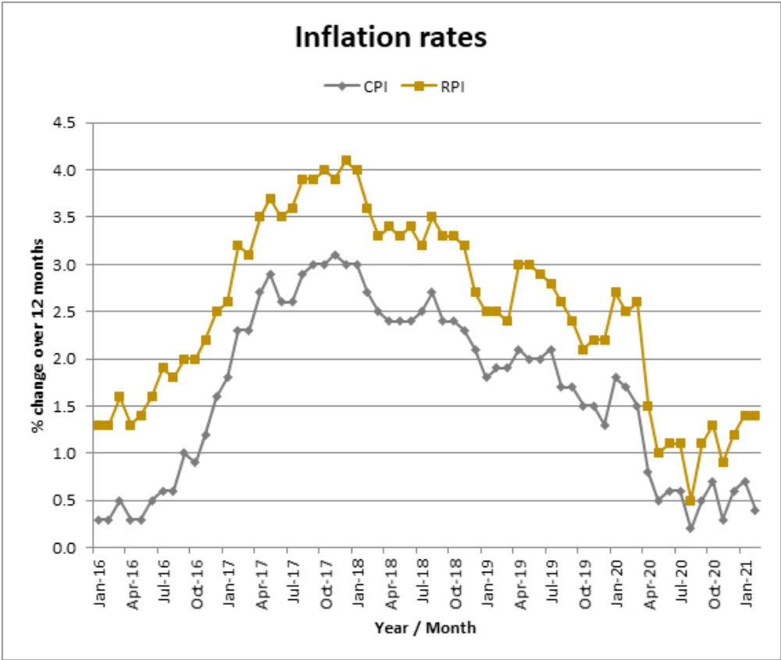

4.2.1 RPI inflation Rate
The retail prices index of inflation was 1.5% in March 2021.

4.2.2 Inflation Forecast
The Treasury average of independent forecasts states that RPI inflation will average 2.4% over 2021. It will then escalate to 2.8% in 2022 and continue to run at around the same mark for the following three years, in line with the pattern shown in graph1 below. These forecasts show the rate at which pay rises would be needed for wages just to maintain their current value.

Graph 1

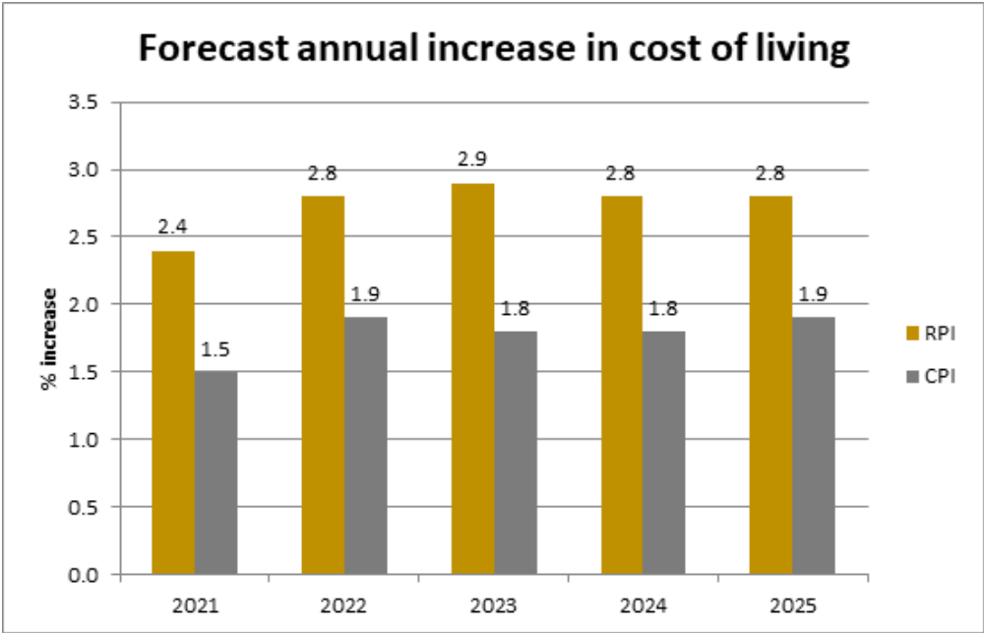

4.2.3 Relationship between RPI and PSC Pay Awards (2011 – 2020)
Graph 2 below shows the relationship between the PSC pay award and RPI inflation since 2011. RPI inflation is shown in brown, the PSC pay award in blue and the disparity between the two in purple.

The PSC pay award has been lower than RPI inflation for the majority of the period in question.
Graph 2

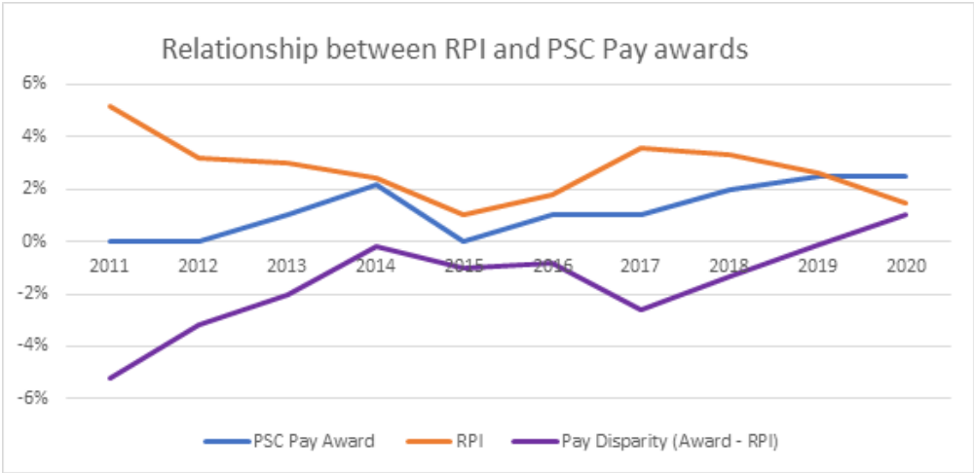
  - Police Service Funding
One of the PSC pay determination factors is the level of police funding for the coming pay year.
2021/22 is the fourth year of real increase in police funding, as set out in the following extract from the ‘Police Grant Report (England and Wales( 2021/22) House of Commons Library Debate Pack (Number CDP-2021/0018, 5 February 2021) :
Assuming all Police and Crime Commissioners in England and Wales maximise their precept income (increasing their precept Band D level by £15) in 2021/22 total direct resource funding, including pensions grant, for England and Wales will increase to just under £13.8 billion in 2021/22 from just under £13.1 billion in 2020/21 - a cash rise of 5.4%:
The Trade Union Side expects this major increase in police funding for this year to be reflected in the eventual police staff pay award for 2021.

- Mixed Percentage/Flat Rate Claim

The Trade Union Side submits a mixed percentage/flat rate claim again this year for the following reasons.

  - Continuing to Address Low Pay
The Trade Union Side acknowledges the progress which was made in the 2017 pay award on low pay with the deletion of PSC pay points 4 and 5, the subsequent deletion of pay point 6 as part of the 2018 pay award, the additional increase given to pay point 7 in the 2019 award, the significant increase in the value of pay point 7 in the 2020 award to ensure that it exceeds the Joseph Rowntree real living wage and the flat rate £501 award to pay points 8-12 in the same year.
The Police Staff Council has therefore demonstrated a real commitment in recent years to tackling low pay. But progress in this respect must be maintained if rates of pay in the lower half of the PSC pay spine are not to fall back in relative value this year and in subsequent pay awards.

5.2 Protecting Police Force Real Living Wage Employer Status
The real living wage, set by the Living Wage Foundation, has become a standard benchmark for the minimum needed for low-paid staff to have a “basic, but acceptable” standard of living.
As a result of last year’s PSC pay award, the minimum hourly rate for police staff on the PSC pay spine is now £9.60/hour. This currently compares favourably with the Joseph Rowntree real living wage for 2020 which is £9.50.
This means that all police forces in England and Wales, which follow PSC agreements, can now call themselves Real Living Wage Employers. This is a fantastic achievement for the Police Staff Council. However, there is an obvious risk that the value of PSC pay point 7 could fall behind the real living wage, as a result of future increases announced by the Real Living Wage Foundation. The annual increase in the real living wage is announced by the Foundation in November each year – two months after the PSC pay award anniversary date of 1 September.
The Trade Union Side is therefore asking for a guarantee that the value of PSC pay point 7 does not fall below the real living wage rate when this rate is announced in November 2021.

5.3 Addressing Pay Drift
A mixed percentage/flat rate award will ensure that the pay drift in favour of pay points in the top half of the pay spine, which always results from straight percentage awards, is ameliorated for those staff on pay points in the lower half of the pay spine.

  - Police Scotland Pay Rates
The minimum pay point for police staff working for Police Scotland is £19,798 with effect from 1 April 2020. This is a result of the implementation of the second year of a two-year award which harmonised the pay and conditions of the former 8 Scottish regional forces and the Scottish Police Services Authority. With the 2021 pay award for Police Scotland staff pending, there is still clearly a big gulf between the lowest pay point for police staff in Scotland and those in England and Wales, which our mixed claim seeks to address.

- A variable increase in the value of pay points 8 – 18 to make each incremental step worth £500 to create more equal steps up the lower pay points of the PSC pay spine

Following the success in last year’s pay award in raising the lowest PSC pay point 7 to above the Joseph Rowntree Real Living Wage, the differential between pay point 7 and pay point 8 has shrunk to only £120 which represents an incremental rise of only 0.65%

Our claim therefore seeks to re-establish a proper differential of £500 between pay points 7 and 8.

In so doing, it is also necessary to even out the jumps between pay points 8 -18 by increasing each pay point by a variable amount to make each increment also worth a suggested £500 (see Appendix A).

Each pay point between 8 and 18 (inclusive) would benefit from an increase in value under this proposal and in most cases the jump between each pay point in this range would also increase in value.

The average value of the increments in the PSC pay spine is 2.8%, but between pay points 8 and 14 they are currently worth a lot less. This part of the claim seeks to address this.

The claim seeks to apply the 3%, or £1,000, headline increase on top of the proposed adjustments to pay points 8 – 18.

- A Review of Police Staff Leave Entitlement
The Trade Union Side is aware of the continuing disparity in police staff annual leave entitlement across forces in England and Wales. There remain a small number of forces which provide only the bare minimum annual leave entitlement provided for by the PSC Handbook, namely 23 days on appointment and 28 days after 5 years service.
The majority of forces have improved on this basic entitlement and provide at least 24, or 25, days annual leave on appointment for their police staff. The Trade Union Side believes that police staff deserve a level playing field when it comes to annual leave, because working for the police service is stressful and staff benefit from time away from work to allow for proper recreation and relaxation.
It is far from clear why a small number of forces are lagging behind the majority when it comes to awarding annual leave which improves on the minimum in the PSC Handbook.
As part of the settlement of our 2018 pay claim, the Employers Side undertook to discuss annual leave entitlement as part of the PSC Pay and Reward Review Part 2. Unfortunately, this has not come to pass over the last two years, despite the Trade Union Side continuing to raise this issue. It is for this reason that we wish the Police Staff Council to undertake a wide ranging review of current leave arrangements for police staff in England and Wales.

- Police Staff Council Pay and Reward Review and Investment in Pay Reform for the Police Workforce

The terms of reference for the PSC Pay and Reward Review commit both Sides of the Council to review the current arrangements for determining police staff basic pay, including job evaluation and pay and grading schemes, and whether these arrangements remain fit for purpose.
This work makes up Part 2 of the PSC Pay and Reward Review, and although much preparatory work has been undertaken by both Sides of the Council, the Employers Side has made it clear that there is no support among forces for fundamental reform of police staff basic pay arrangements. This is a matter of real concern to the Trade Union Side.

The Trade Union Side is aware that in relation to the police officer part of the police workforce, the Employers are committed to a programme of pay reform which is likely to require additional investment in police officer pay to deliver.

We make clear again on behalf of our members that we expect any additional investment in police officer pay arrangements, connected with pay reform, to be matched by no lesser degree of additional investment in our members’ pay arrangements.

- Conclusion
The Police Staff Council Trade Union Side submits this claim in the expectation that police staff will receive a proper pay rise in 2021. Our claim is reasonable and proportionate, particularly given the drastic decline in the value of our members’ earnings over the last ten years and in relation to the sterling work which our members have been carrying out in relation to the police service response to the covid19 pandemic.
The Police Staff Council pay determination factors clearly justify a decent pay rise for police staff this year. This claim highlights in particular that RPI inflation remains high, that public sector pay awards are up, and also that 2021/22 has seen the fourth increase in police service funding for many years; a very noteworthy 5.4% increase at that. These are the significant economic factors which will inform this year’s pay negotiations.
This claim also seeks to maintain the progress we have made on the Council in tackling low pay, by ensuring that pay point 7 never again falls below the Joseph Rowntree real living wage and that pay drift from straight percentage awards is ameliorated by flat rate awards for staff in the lower half of the pay spine.
Finally, the claim highlights the determination of the Trade Union Side to see the Police Staff Council review leave entitlement for police staff, to deliver on its agreed terms of reference for the Pay and Reward Review, and for an even-handed approach to investment in pay reform across the whole workforce.

APPENDIX A
SWP SCP | National SCP | 2020 Pay Point | Current Value of Increment | Current % Value of Increment | Proposed 2021 Pay Point | Increase on 2020 Increment | Proposed % Value of Increment
11 | 7 | £18,501 |  |  | £18,501
12 | 8 | £18,621 | £120 | 0.65% | £19,001 | £380 | 2.70%
13 | 9 | £19,032 | £411 | 2.21% | £19,501 | £469 | 2.63%
14 | 10 | £19,452 | £420 | 2.21% | £20,001 | £549 | 2.56%
15 | 11 | £19,860 | £408 | 2.10% | £20,501 | £641 | 2.50%
16 | 12 | £20,274 | £414 | 2.08% | £21,001 | £727 | 2.44%
17 | 13 | £20,706 | £432 | 2.13% | £21,501 | £795 | 2.38%
18 | 14 | £21,135 | £429 | 2.07% | £22,001 | £866 | 2.33%
19 | 15 | £21,876 | £741 | 3.51% | £22,501 | £625 | 2.27%
20 | 16 | £22,599 | £723 | 3.30% | £23,001 | £402 | 2.22%
21 | 17 | £23,406 | £807 | 3.57% | £23,501 | £95 | 2.17%
22 | 18 | £23,817 | £411 | 1.76% | £24,001 | £184 | 2.13%
23 | 19 | £24,546 | £729 | 3.06% | £24,546 |  | 2.27%
24 | 20 | £25,278 | £732 | 2.98% | £25,278 |  | 2.98%
25 | 21 | £26,012 | £734 | 2.90% | £26,012 |  | 2.90%
26 | 22 | £26,865 | £853 | 3.28% | £26,865 |  | 3.28%
27 | 23 | £27,774 | £909 | 3.38% | £27,774 |  | 3.38%
28 | 24 | £28,725 | £951 | 3.42% | £28,725 |  | 3.42%
29 | 25 | £29,793 | £1,068 | 3.72% | £29,793 |  | 3.72%
30 | 26 | £30,777 | £984 | 3.30% | £30,777 |  | 3.30%
31 | 27 | £31,725 | £948 | 3.08% | £31,725 |  | 3.08%
32 | 28 | £32,673 | £948 | 2.99% | £32,673 |  | 2.99%
33 | 29 | £33,618 | £945 | 2.89% | £33,618 |  | 2.89%
34 | 30 | £34,578 | £960 | 2.86% | £34,578 |  | 2.86%
35 | 31 | £35,484 | £906 | 2.62% | £35,484 |  | 2.62%
36 | 32 | £36,396 | £912 | 2.57% | £36,396 |  | 2.57%
37 | 33 | £37,281 | £885 | 2.43% | £37,281 |  | 2.43%
38 | 34 | £38,376 | £1,095 | 2.94% | £38,376 |  | 2.94%
39 | 35 | £39,585 | £1,209 | 3.15% | £39,585 |  | 3.15%
40 | 36 | £40,662 | £1,077 | 2.72% | £40,662 |  | 2.72%
41 | 37 | £41,718 | £1,056 | 2.60% | £41,718 |  | 2.60%
42 | 38 | £42,783 | £1,065 | 2.55% | £42,783 |  | 2.55%
43 | 39 | £43,860 | £1,077 | 2.52% | £43,860 |  | 2.52%
44 | 40 | £44,928 | £1,068 | 2.44% | £44,928 |  | 2.44%
45 | 41 | £45,996 | £1,068 | 2.38% | £45,996 |  | 2.38%
46 | 42 | £47,058 | £1,062 | 2.31% | £47,058 |  | 2.31%
47 | 43 | £48,123 | £1,065 | 2.26% | £48,123 |  | 2.26%
48 | 44 | £49,182 | £1,059 | 2.20% | £49,182 |  | 2.20%
49 | 45 | £50,250 | £1,068 | 2.17% | £50,250 |  | 2.17%

APPENDIX B
SWP SCP | SCP | 2020 plus Incremental Adjustment SCP 8-18 | 3% or £1,000 whichever is the greater
11 | 7 | £18,501 | £19,501
12 | 8 | £19,001 | £20,001
13 | 9 | £19,501 | £20,501
14 | 10 | £20,001 | £21,001
15 | 11 | £20,501 | £21,501
16 | 12 | £21,001 | £22,001
17 | 13 | £21,501 | £22,501
18 | 14 | £22,001 | £23,001
19 | 15 | £22,501 | £23,501
20 | 16 | £23,001 | £24,001
21 | 17 | £23,501 | £24,501
22 | 18 | £24,001 | £25,001
23 | 19 | £24,546 | £25,546
24 | 20 | £25,278 | £26,278
25 | 21 | £26,012 | £27,012
26 | 22 | £26,865 | £27,865
27 | 23 | £27,774 | £28,774
28 | 24 | £28,725 | £29,725
29 | 25 | £29,793 | £30,793
30 | 26 | £30,777 | £31,777
31 | 27 | £31,725 | £32,725
32 | 28 | £32,673 | £33,673
33 | 29 | £33,618 | £34,627
34 | 30 | £34,578 | £35,615
35 | 31 | £35,484 | £36,549
36 | 32 | £36,396 | £37,488
37 | 33 | £37,281 | £38,399
38 | 34 | £38,376 | £39,527
39 | 35 | £39,585 | £40,773
40 | 36 | £40,662 | £41,882
41 | 37 | £41,718 | £42,970
42 | 38 | £42,783 | £44,066
43 | 39 | £43,860 | £45,176
44 | 40 | £44,928 | £46,276
45 | 41 | £45,996 | £47,376
46 | 42 | £47,058 | £48,470
47 | 43 | £48,123 | £49,567
48 | 44 | £49,182 | £50,657
49 | 45 | £50,250 | £51,758

